Exploring the Linux File System

**Part 1: Understanding the Linux File System**

1. Basic concepts of the Linux File System :

- Root Directory(/) : The top-level directory in the Linux file system. It is the starting point for the entire file hierarchy.
- File Hierarchy : The structure and organization of files and directories in a Linux system. It follows a tree-like structure with the root directory at the top.
- Permissions : File and directory access control settings that determine who can read, write, and execute files. Permissions are typically defined for three categories: owner (user), group, and others.
- File Types : In Linux, files can be categorized as regular files, directories, symbolic links, device files, socket files, and more.

2. Annotated Linux File System Hierarchy :

Here’s an annotated diagram of the Linux file system hierarchy :

/ (Root Directory)
|-- bin (Essential system binaries)
|-- etc (System configuration files)
|-- home (User home directories)
| |-- user1
| |-- user2
| |-- ...
|-- var (variable data, e.g., logs and caches)
|-- tmp (temporary files)
|-- dev (device files)
|-- lib (system libraries)
|-- usr (user executables and data)
| |-- bin (user binaries)
| |-- lib (user libraries)
| |-- ...
|-- opt (optional software packages)
|-- srv (service data)
|-- mnt (mount points for external devices)
|-- media (mount points for removable media)
|-- proc (kerenl and process information)
|-- sys (kernel-related information)

3. Permissions in Linux :

In Linux,file permissions determine who can access and manipulate files and directories.
Each file has three stes of permissions :
- Owner : the user who owns the file or directory.
- Group : users who belong to the same group as the file.
- Others : Everyone else who is not the owner or in the group.

The permission types are :

- Read (r) : Allows users to view the content of a file or list the contents of a directory.
- Write (w) : Permits users to modify the contents of a file or add, remove, or rename files within a directory.
- Execute (x) : Grants users permission to execute a file (e.g., run a script or binary) or access the contents of a directory.

Examples of permission setting and their meanings :

- rwxr -xr -- : The owner has read, write, and execute permissions, while the group has read and execute permissions. Others have only read access.
- Rw-rw-rw- : All users (owner, group, and others) have read and write access, making the file completely editable by anyone.
- rwx------ : The owner has full control, including read, write, and execute, while no one else has any access.

**Part 2: Hands-On Exploration**

1. Terminal Basics :

- ls : it will list all files and directories in the current directory.
- cd : it will change the current directory.
- pwd : prints the path of the working directory.
- mkdir : it is used to create a new directory.

2. File Manipulation : Create a directory structure with at least three nested directories and various files inside them. Use commands like `touch`, `mkdir`, `mv`, `cp`, and `rm` to manipulate files and directories within your structure.

- Creating a directory structure and manipulating files and directories. Here’s an example :

- Use the below command to create a directory :
mkdir my_folder # It will create a directory named my_folder.
- Change the current directory to my_folder :
cd my_folder
- create a nested directories in my_folder :
mkdir dir1 dir2
- create a files inside the directories using touch command :
touch file1 file2 file3
- create a subdirectory inside dir1 :
mkdir dir1/subdir1
- create a fiel inside a dir1 :
touch dir1/file4
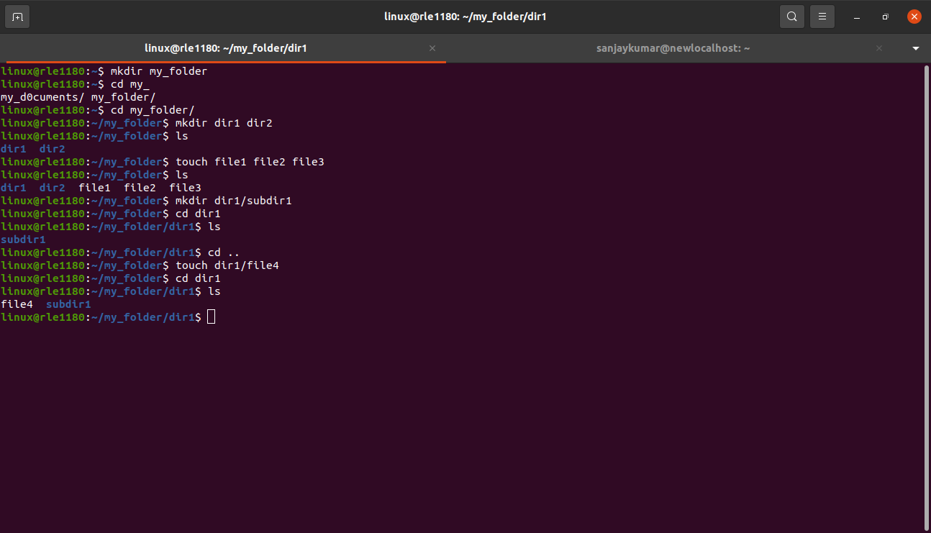
- move, copy and remove files and directories :

- mv file1 dir1/subdir1/
It will move file1 to subdir1
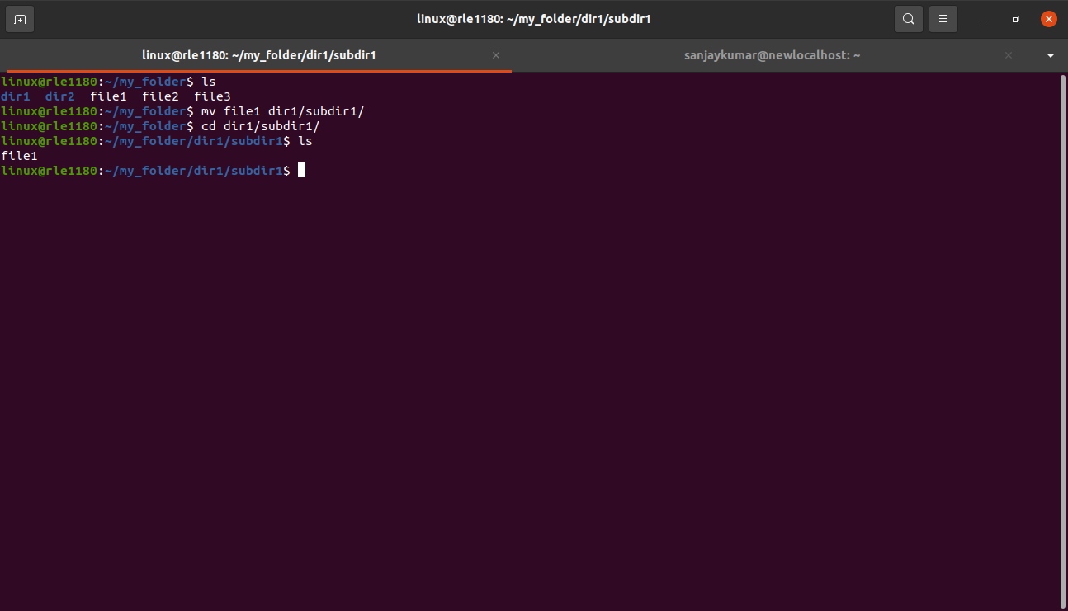
- cp file2 dir2/
It will copy file2 to dir2
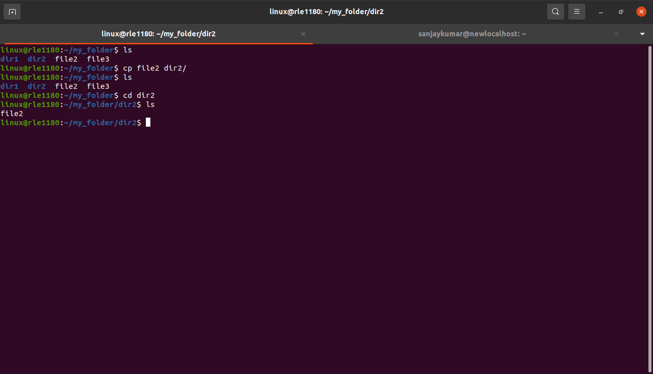
- rm file3
It will remove file3 from the directory.
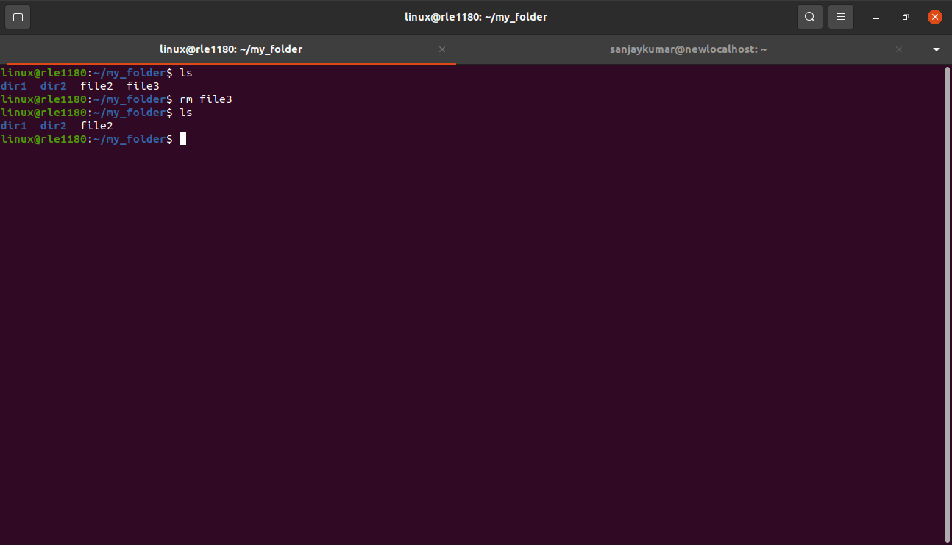
- Rm -r dir1
It will remove the directory dir1 and its contents.
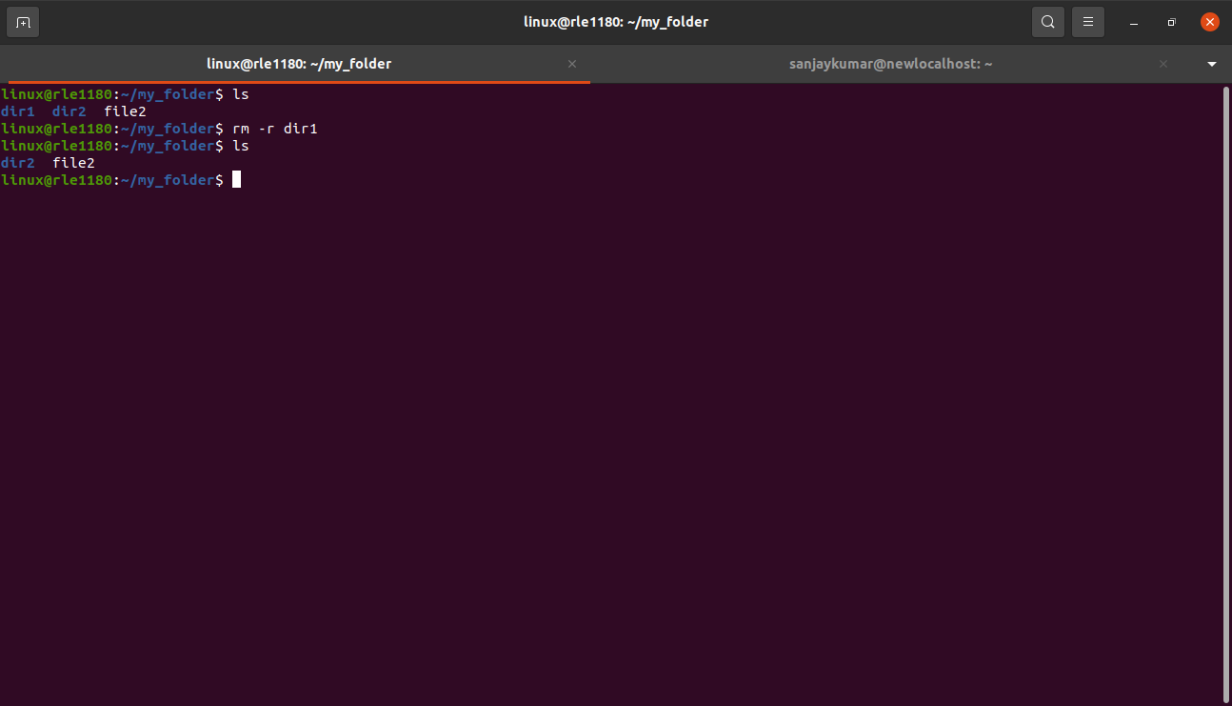
3. Permissions and Ownership: Experiment with changing file permissions using commands like `chmod` and changing file ownership using `chown` and `chgrp`. Discuss the consequences of altering permissions and ownership.

- chmod : use this command to modify file permissions. For example :
chmod +x <filename> #makes a file executable.
Ex : chmod +x file2
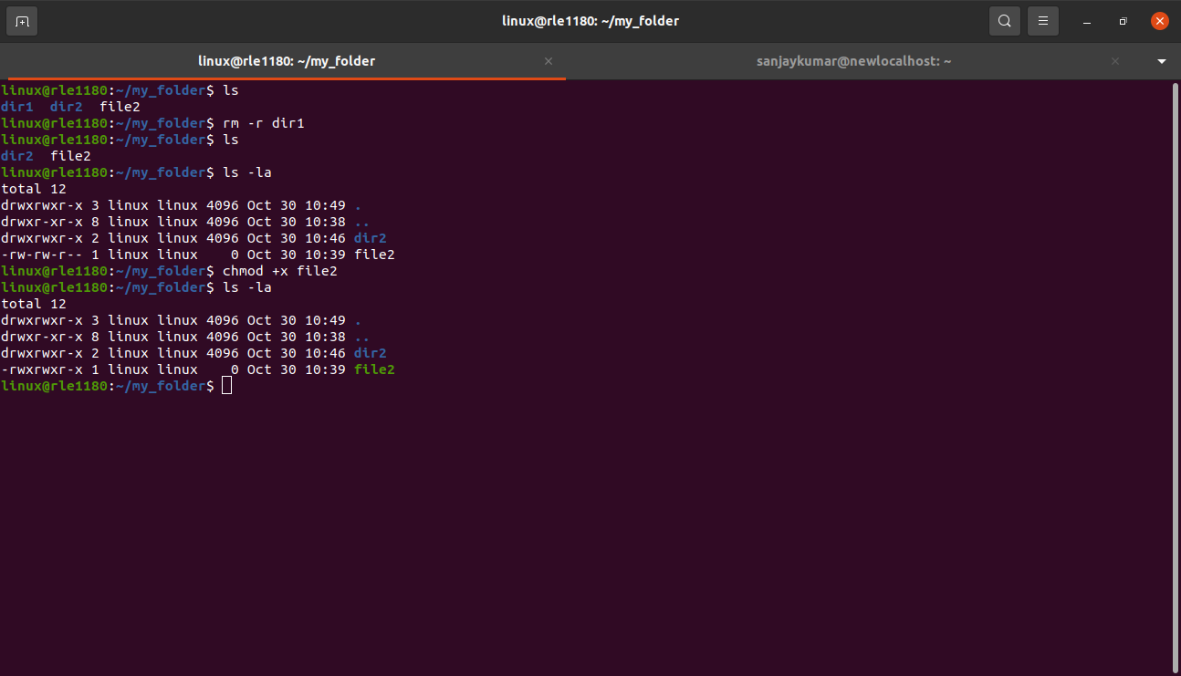
- chmod 644 <filename> #sets read and write permissions for the owner and read-only for others.
Ex : chmod 644 file2
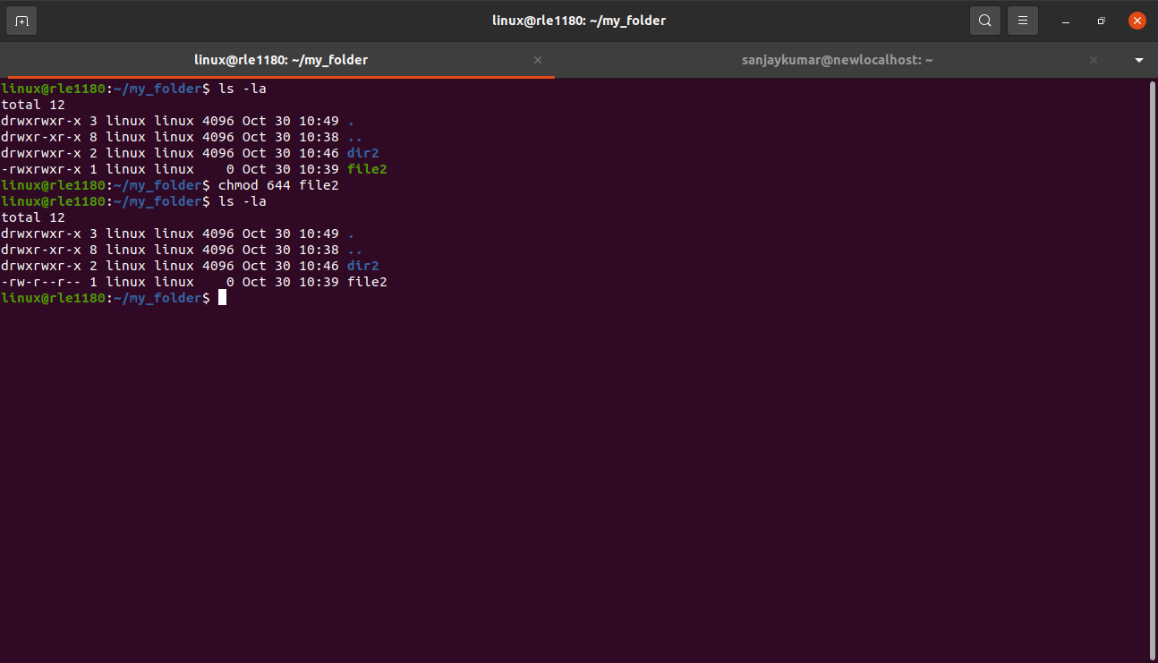
- chmod a-rwx <filename> # it will remove all permissions.
- chmod u+rw <filename> # it will give read and write permission only for owner.
- chmod o+rwx <filename> # it will all three permissions for other users
- ‘chown’ and ‘chgrp’ : These commands allow you to change the ownership of a file or directory.
- chown : to change the user ownership.
- chgrp : to change group ownership.

Consequences of altering permissions and ownership :

- Changing permissions can impact who can access or modify files.
- Changing ownership can restrict or grant control over files. Ensure that the correct users and groups own specific files,particularly in multi-user environments.

**Part 3: Advanced Tasks**

1. Scripting: Write a simple shell script that automates a series of file operations, such as creating directories, copying files, and changing permissions. Execute the script and explain its functionality.

- Create a directory called my_script_dir by using the command :
mkdir my_script_dir
- create a file called file1.txt and file2.txt by using the command :
touch file1.txt
touch file2.txt
- Create a file inside the my_script_dir (e.g., file_operations.sh.) :
Sudo touch file_operations.sh
- write the script inside the file_operations.sh by using the command :
sudo nano file_operations.sh
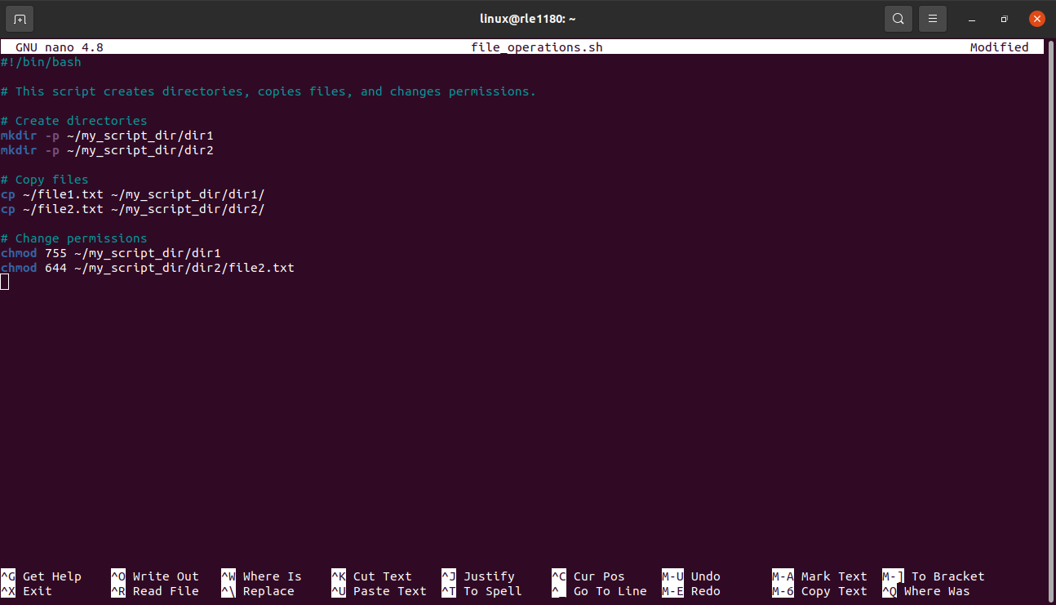
- Make the script executable with the command :
chmod +x file_operations.sh
- execute the script using ./file_operations.sh.

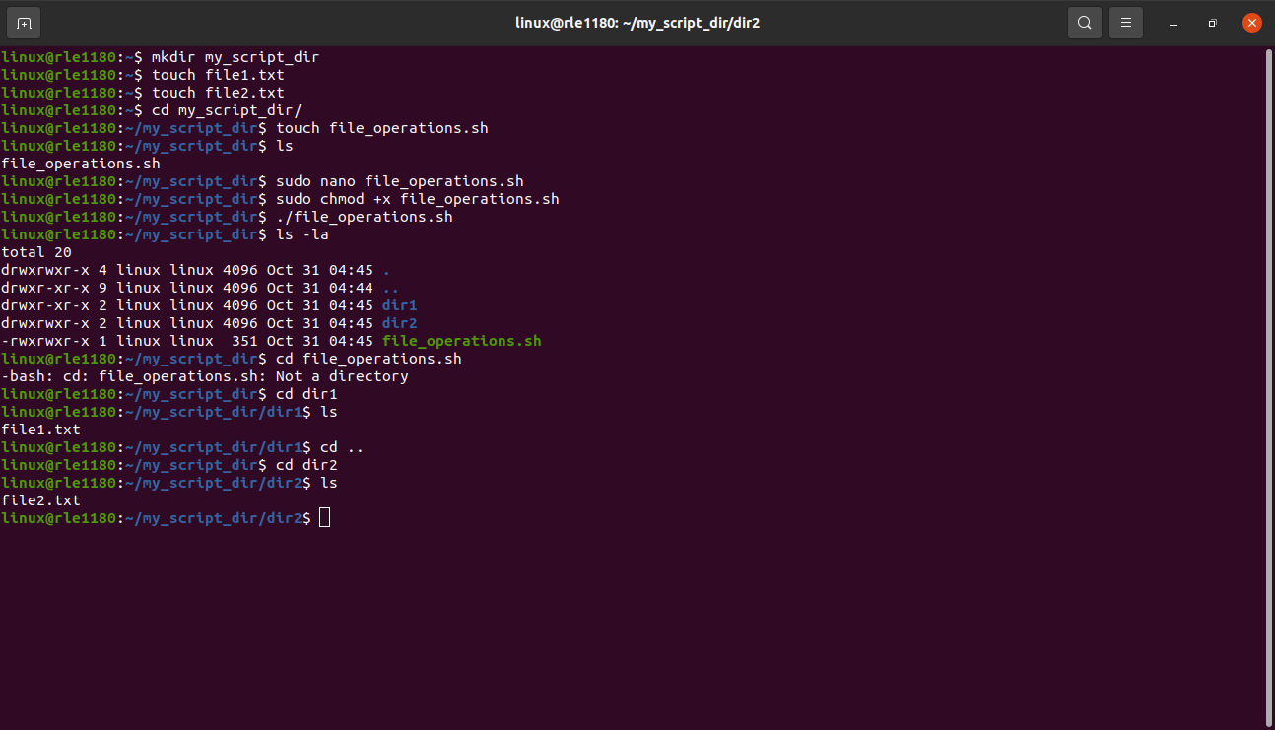
- After execution the script will create two directories (dir1 and dir2) inside my_script_dir.
- It will copy file1.txt into dir1 and copy file2.txt into dir2.
- It will also set specific permissions on the directoriesand the file2.txt file.

4. symbolic links :

Symbolic links, often referred to as “symlinks” or “soft links” are pointers to another
file or directory. They act as references to the original file or directory and can be used to create shortcuts or references in the linux file system.

Key characteristics of symbolic links :

- symlinks can point to files or directories.
- They can span different file systems and even across network shares.
- Symlinks can link to non-existent files or directories.
- When the original file or directory is moved or renamed, the symlink remains valid.

Difference between symbolic links and hard links :

- physical vs logical :
  - A hard link is a second physical reference to the same data blocks on the storage device. Changes to one hard link affect all hard links because they point to the same underlying data.
  - A symbolic link is a separate file that contains the path to the target file or directory. It’s more like a pointer and changes do not affect the target file.
2. Cross-File System links :
- Hard links cannot span different file systems or partitions.
- Symbolic links can span different file systems and partitions.
3. Original File Deletion :
- If the original file is deleted,hard links will still access the data.
- If the original file is deleted, a symbolic link becomes “dangling” and points to a non-existent file.

